# CSS-Basics-Lab

*In today's exercise, we will build a very simple page in which we will practice everything from the lesson learned about HTML lecture. We will build it step by step following the instructions below.*

## Heading stage upgrade

Use your HTML code from the previous lecture

Make your headings (**h1**) **inline** with **color blue**

### Examples



## Paragraph stage upgrade

Use your HTML code from the previous lecture

Make all **paragraphs** with **internal style** with **color darkviolet**

### Examples

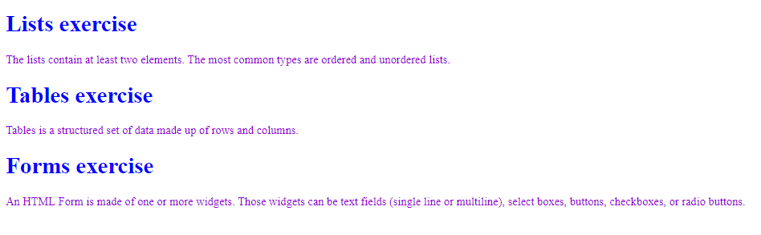

## Code refactor

Delete all the styles you have made

Open the styles from the HTML lecture

Link the CSS file into your HTML file

Add in the CSS file, the styles you have deleted

## List/Table/Form stage upgrade

Use your HTML code from the previous lecture

Make all list elements (<li>) with solid border in yellow color

### Examples

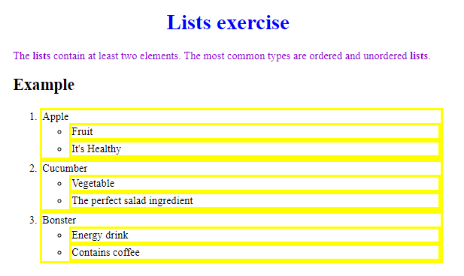

Use your HTML code from the previous lecture

Make all your **spans** with **dotted border** in **darkcyan color**

### Examples

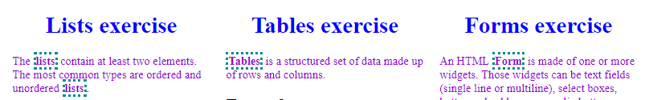

## Color Blocks

Use the following HTML

|  |
| --- |
| <**body**> <**div id="green"**>green block</**div**> <**div id="blue"**>blue block</**div**> <**div id="red"**>red block</**div**> <**div id="purple"**>purple block</**div**> <**div id="orange"**>orange block</**div**> </**body**> |

### Examples

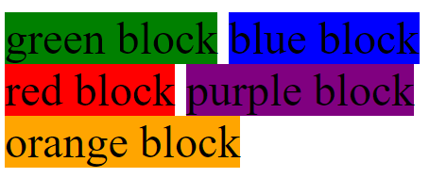

## Color Blocks upgrade

Use the HTML and CSS from the previous problem

Make all **<div> padding 20px** on each side, refresh the browser

Set **3px** **solid**, **border** with **yellow color**, refresh the browser

Now set **margin** with **20px** for each side, refresh the browser

### Examples

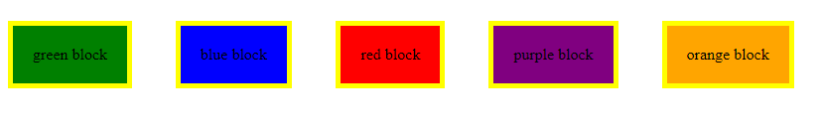

## Cool Fonts

Use the code from the previous problem

Go to <https://fonts.google.com/>

Pick a font of your preference

Click on the "+" in the top-right corner

Click on the new opened tab

Copy the link in your HTML <head>

Copy the font family in your <div>

### Examples

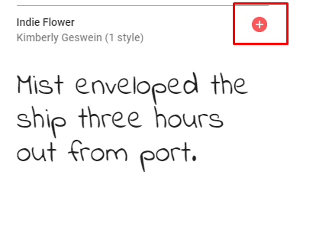



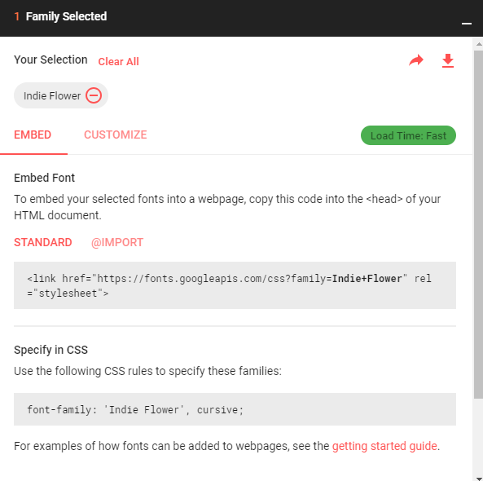

## Cool Fonts upgrade

Use the code from the previous problem

Set **large font-size**

Set **bold font-weight**

### Examples

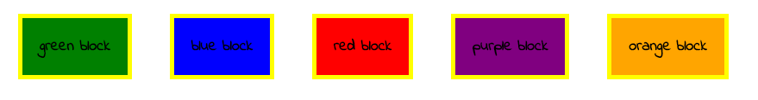

Use the code from the previous problem

In your **<div>** set **white color**

### Examples



*And we are done! ☺*